CS 340 README

About the Project/Project Title:
The full-stack dashboard in this project, which was constructed using Python, Dash, and MongoDB, is intended to provide a user-friendly interface and execute reliable CRUD operations. It exhibits data integration, backend programming abilities, and interactive user interface elements designed for practical data administration.

Motivation:
The goal is to provide a working environment for Grazioso Salvare to help identify dogs for training. These animals must be two years old or younger. They also demand specific breeds for their program. They seek a software program that can integrate with an existing database of animal shelters in the Austin, Texas area. This program will assist them in narrowing down their search for animals for their search and rescue training.

Features:
- User Authentication: Secure login system with session management
- CRUD Operations: Create, Read, Update, Delete records directly from the dashboard
- Interactive Widgets: Data tables, dropdowns, and charts for dynamic filtering and visualization
- MongoDB Integration: Real-time data retrieval and updates using PyMongo
- Responsive Layout: Clean, beginner-friendly interface with modular design

Technologies Used:
- Python 3.10+
- DASH by Plotly
- MongoDB
- Pandas
- Jupyter Notebook
- Microsoft Word

Usage:
- Log in with valid credentials
- Use dropdowns and filters to explore data
- Create, update, or delete records using the form
- Read changes reflected instantly in the dashboard

Highlights:
- Fully working backend with MongoDB.
- Clean UI with interactive components.
- Well-documented code and modular structure.
- Meets or exceeds Grazioso Salvare requirements.

Challenges:
- Finding Callback and Traceback Error/Errors and Repairing Error/Errors
- Locating multiple syntax errors within the code.

Functionality Screenshots:
- Proof of connection and Location of DASH application
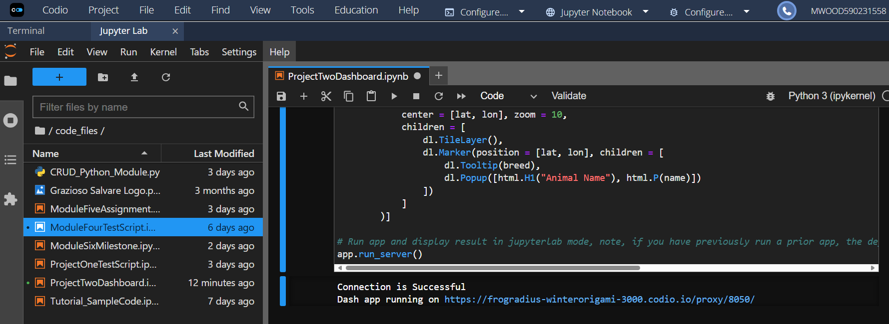
- Start Page of application, showing no errors
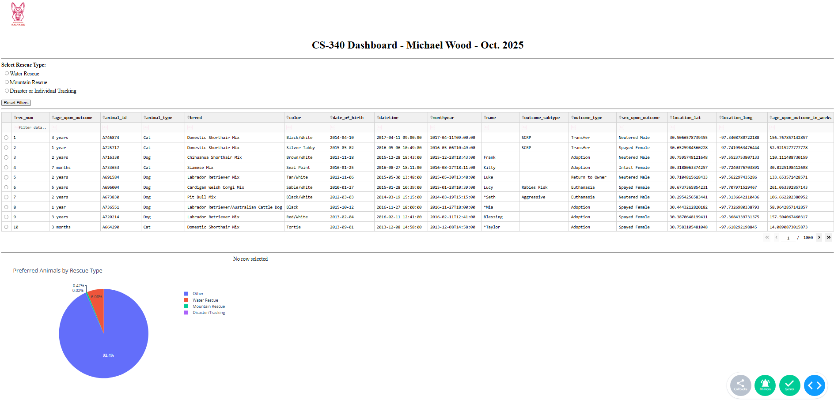

- Selecting Water Rescue and Potential Dog (Map shows where animal is located).
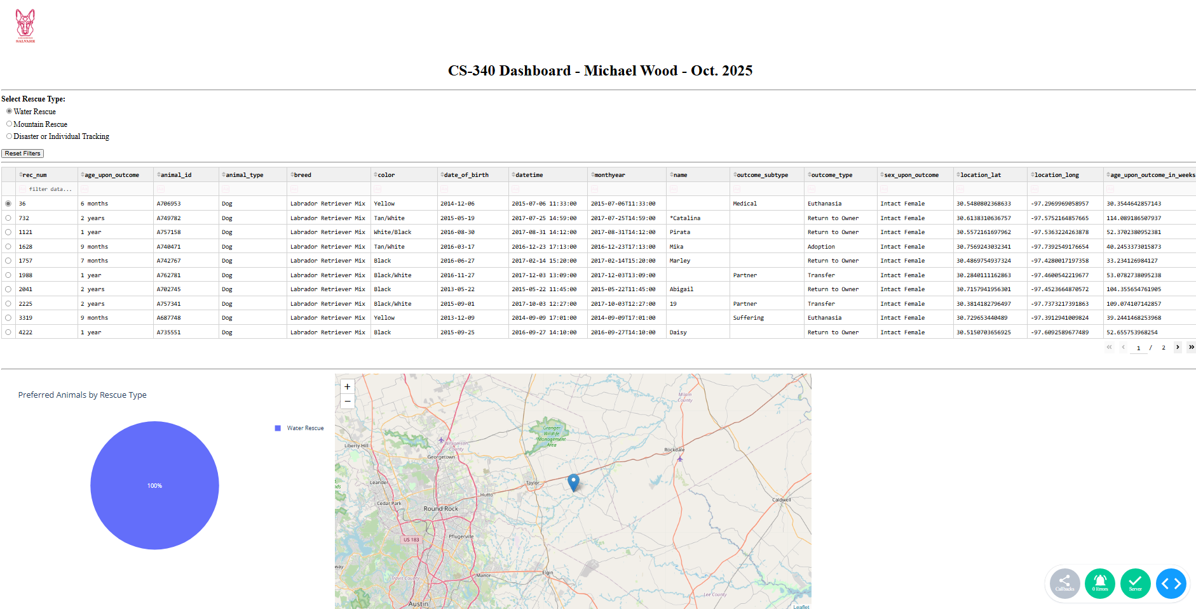
- Selecting Mountain Rescue and Potential Dog (Map shows where animal is Located)
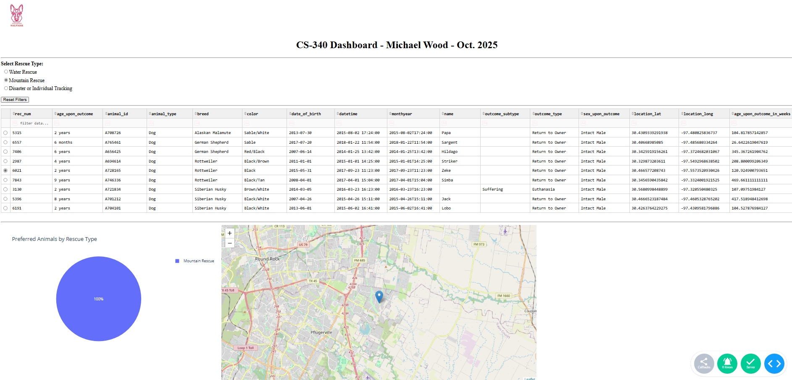
- Selecting Disaster or Individual Tracking and Potential (Map shows where animal is Located)
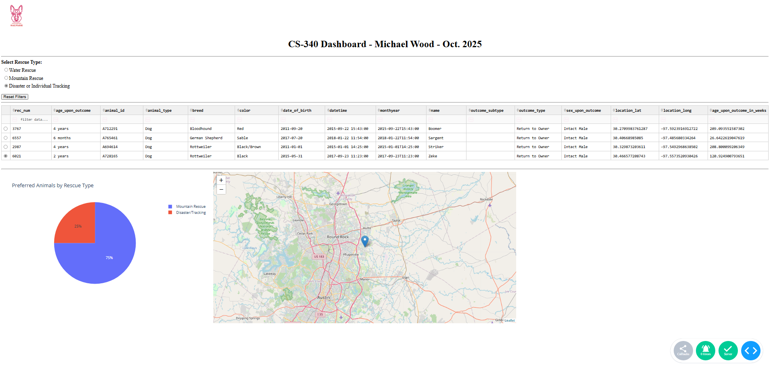

- Reset Filters which Returns App to Main List of All Animals
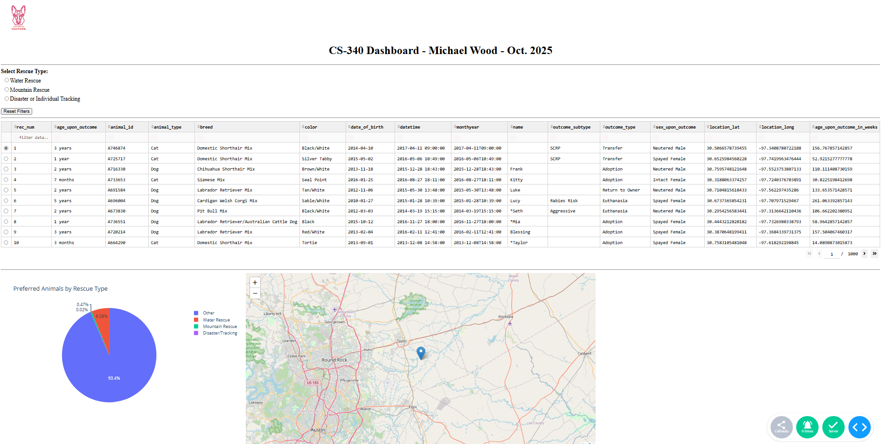

Steps for Completion:
- Read and Understand Project Requirements
- Set-up Codio Environment
- Install Required Packages
- Connect to MongoDB
- Build DASH App
- Implement CRUD Procedures
- Test Functionality
- Refine and Improve User Interface
- Write README
- Capture and Implement Them into the README document
- Clean Up Files and Code
- Final Review

Links to Applications Used:
- Codio - Codio Learning Environment
- Dash
- Project Two Guidelines and Rubric - CS-340-10392-M01 Client/Server Development 2025 C-5 (Sep - Oct)

Description of Tools:
- MongoDB - MongoDB was used in your CS-340 dashboard project because of its adaptable, schema-free document model, which made it ideal for storing diverse and changing data types, particularly in a user-centric dashboard. Its fast and straightforward CRUD procedures worked perfectly with your backend Python and REST API configuration, allowing for rapid data handling and real-time updates. MongoDB's ability for nested documents and arrays made it easier to express complex UI elements such as charts and filters, while its robust aggregation pipeline and geospatial queries allowed for advanced features like grouped pie charts and location-based visualizations. With seamless integration into Dash and Jupyter, you can query, clean, and visualize data immediately within your app, helping you achieve your objective of creating a strong, beginner-friendly, and visually intuitive solution.
- DASH - Dash is a Python framework for managing both the view and controller layers of a web application. It allows you to create the user interface using Python code to design HTML elements and interactive components, and its callback mechanism serves as the controller, connecting user inputs to outputs such as charts or tables. This approach allows you to easily construct dynamic, data-driven dashboards without the need for separate frontend code, keeping everything in one tidy, Python-based workflow.

Contact
Your name: Michael Wood

